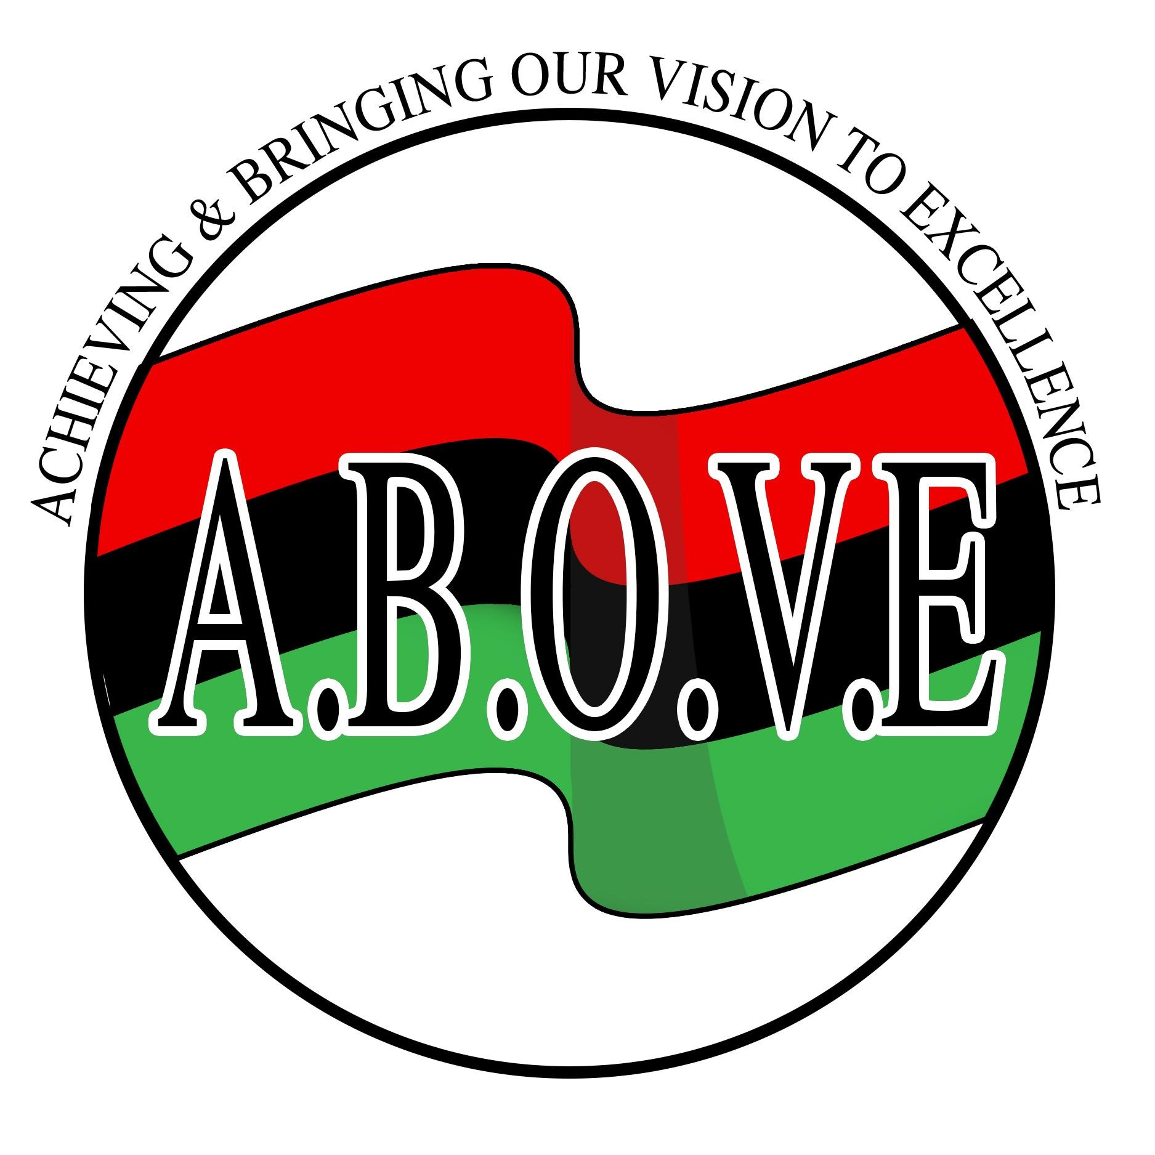 A.B.O.V.E
(Achieving & Bringing Our Vision to Excellence)
A.B.O.V.E. (Achieving & Bringing Our Vision to Excellence) is pleased to present its sixteenth annual Pan Afrikan Festival, Saturday, August 1, 2026 at Highland Bowl Park in Rochester, New York from 12 pm to 7 pm.
The purpose of this special day is to celebrate our heritage and culture through music, dance, art, literature, education and spoken word. In addition, the festival will build unity, pride, and self-esteem to improve the quality of life in our community. There will be an area for children that will include inflatables, carnival games, and storytelling from 12-4pm.
The event is open to the public and attendance is encouraged among people of all ethnic and cultural backgrounds. Therefore, we encourage everyone to come and join us in the festivities.
We are seeking your support by purchasing an ad to display your company’s logo/ name on our festival website and/or stage banner to proceed with the planning of this event. The website logo/ad will be placed on our website at https://panaffestival.org/. The banner will be displayed across the stage and viewed by all participants/attendees of the festival! The price is as follows:
Stage Banner Logo recognition – $500.00 (banner price is the same for both color or black and white ads)
Stage Patron (Name) recognition – $250.00
Website (only) Logo/Name recognition - $150.00
*Please send 6” x 4” Jpeg to https://panaffestival.org/
P.O. Box 1236 ▪ Webster, NY 14580 ▪ Phone (585) 935-1068
“Strengthening Our Community Through Arts, Culture and Education”
Website: https://panaffestival.org/ Email: info@panaffestival.org
A.B.O.V.E
(Achieving & Bringing Our Vision to Excellence)
Company/Individual Name _________________________________________________ Contact Information:
Name __________________________________ Title ___________________________
Address ________________________________________________________________
City _________________________________ State _____________ Zip _____________
Phone ________________________________ Fax ___________________________
E-mail __________________________________________________________________
Signature_________________________________________ Date___________________
My Signature indicates authorization to make this commitment on behalf of my company.
YES! We want to support A.B.O.V.E. Pan Afrikan Festival on Saturday, August 1, 2026. Please note that the deadline is July 1, 2026.
Stage Banner logo ad - $500.00 _____________
Stage Banner Patron ad - $250.00 _____________
Website (only) logo/Patron ad - $150.00 _____________

Please make payments online @ https://panaffestival.org/ or mail this form and make checks payable to and mail this form to:
A.B.O.V.E.
PO Box 1236
Webster, NY 14580
Thank you for your contribution!
This contribution qualifies for a charitable tax deduction.
P.O. Box 1236 ▪ Webster, NY 14580 ▪ Phone (585) 935-1068
“Strengthening Our Community Through Arts, Culture and Education”
Website: https://panaffestival.org/ Email: info@panaffestival.org

